Canvas is Jericho’s Learning Management System. It will keep you informed of your child’s homework and class assignments.

Parent Canvas accounts for new sign-up

On a computer using Google Chrome or Firefox

https://jerichoschools.instructure.com/register_from_website

Select Parents sign up here

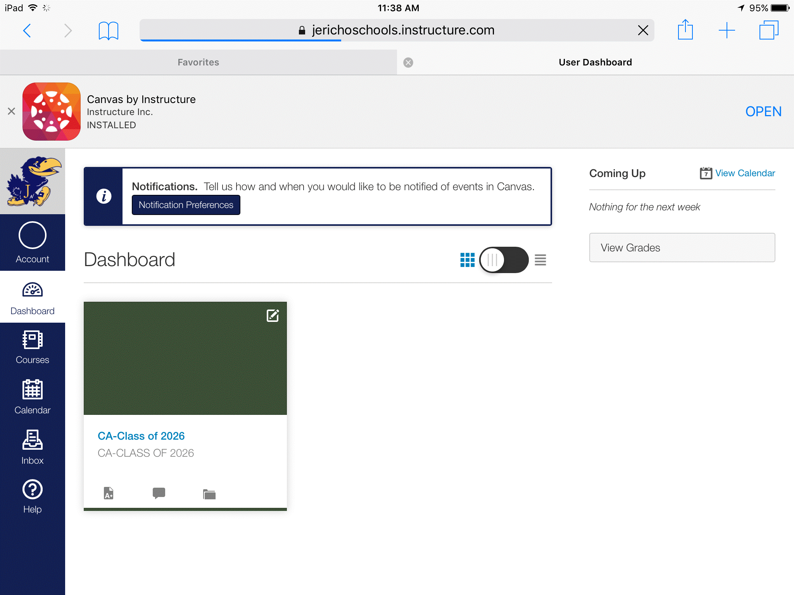

Your child’s courses will show in the dashboard

In the upper left- if you select account - you can adjust notifications settings to your preferences

Oh us